**School Bus Monitoring and Management System**

Software Requirements Specification

Version 2.0

2016/December/21

Norah alkhunifer

Lama alrashed

Lead Software Engineer

Prepared for

SWE 312—Software Requirements Engineering

Fall 2016

# Revision History

|  |  |  |  |
| --- | --- | --- | --- |
| **Date** | **Description** | **Author** | **Comments** |
| <date> | <Version 1> | <Your Name> | <First Revision> |
| 28-Nov-2016 | Requirements, use case, general description, introduction | Nora, Lama |  |
| 21-Dec-2016 | Class Diagram, use case descriptions Mockup screens, Sequence Diagrams, Activity Diagrams | Nora, Lama |  |
|  |  |  |  |

# Document Approval

The following Software Requirements Specification has been accepted and approved by the following:

|  |  |  |  |
| --- | --- | --- | --- |
| **Signature** | **Printed Name** | **Title** | **Date** |
|  | <Your Name> | Lead Software Eng. |  |
|  |  |  |  |
|  |  |  |  |

**Table of Contents**

**REVISION HISTORY**

**DOCUMENT APPROVAL**

**1. INTRODUCTION**

1.1 Purpose

1.2 Scope

1.3 Definitions, Acronyms, and Abbreviations

1.4 References

1.5 Overview

**2. GENERAL DESCRIPTION**

2.1 Product Perspective

2.2 Product Functions

2.3 User Characteristics

2.4 General Constraints

2.5 Assumptions and Dependencies

**3. SPECIFIC REQUIREMENTS**

3.1 External Interface Requirements

*3.1.1 User Interfaces*

*3.1.2 Hardware Interfaces*

*3.1.3 Software Interfaces*

3.2 Functional Requirements

*3.2.1 <Functional Requirement or Feature #1>*

*3.2.2 <Functional Requirement or Feature #2>*

3.3 Use Cases

*3.3.1 Use Case #1*

*3.3.2 Use Case #2*

3.4 Classes / Objects

*3.4.1 <Class / Object #1>*

*3.4.2 <Class / Object #2>*

3.5 Non-Functional Requirements

*3.5.1 Performance*

*3.5.2 Reliability*

*3.5.3 Availability*

*3.5.4 Security*

*3.5.5 Maintainability*

*3.5.6 Portability*

3.6 Inverse Requirements

3.7 Design Constraints

3.8 Logical Database Requirements

3.9 Other Requirements

**4. ANALYSIS MODELS**

4.1 Sequence Diagrams

4.3 Activity Diagram

**5. CHANGE MANAGEMENT PROCESS**

**A. APPENDICES**

A.1 Appendix 1

A.2 Appendix 2

# 1. Introduction

# 1.1 Purpose

The purpose of the document is to collect and analyze all assorted ideas that have come up to define the system, its requirements with respect to consumers. Also, we shall predict and sort out how we hope this product will be used in order to gain a better understanding of the project, outline concepts that may be developed later, and document ideas that are being considered, but may be discarded as the product develops.

In short, the purpose of this SRS document is to provide a detailed overview of our software product, its parameters and goals. This document describes the project's target audience and its user interface, hardware and software requirements. It defines how our client, team and audience see the product and its functionality. Nonetheless, it helps any designer and developer to assist in software delivery lifecycle (SDLC) processes.

## 1.2 Scope

The School Bus Monitoring and Management System is a cooperation of Android application and website. the system helps KG, intermediate and high school students, and should support: bus driver, admin and parents. SBM2S is intended to assist bus drivers with route planning, inform parents about state of buses, improve inter-bus transfers by informing admin by any satiation.

## 1.3 Definitions, Acronyms, and Abbreviations

## GPS (Global Position System): A system of satellites, computers, and receivers for determining the position of a receiver on Earth.

SBM2S (School Bus Monitoring and Management System): A system to be sold to schools in Riyadh to help these schools better monitor and manage their school bus service.  
 capacity: A bus capacity is the number of students that the bus can accommodate.  
 CVRP (Capacitated Vehicle Routing Problem): efficient algorithms where Routes are computed such that the total distance that the buses travel is minimized while respecting the capacities of buses.

Destination: The geographic location where the students completes their trip. In the system it is

## 1.4 References

Bus Tracking System, February 2, 2006, Acorn Software.   
E-Store Project,04/15//07, Marvel Electronics and Home Entertainment.

## Overview

*The remaining sections of this document provide a general description, including Product Perspective, Product Functions and characteristics of the users of this project and the Assumptions and Dependencies. General description of the project is discussed in section 2 of this document. Section 3 gives the functional requirements, nonfunctional requirements and design constraints. Section 3 also gives detailed description of functional requirements.*

# 2. General Description

## 2.1 Product Perspective

## *The bus monitoring system is made up of the following components:*

*-Central server that connect several smart phones carried out by bus drivers and students’ parents.  
- A GPS-enabled system located on each bus that will send bus location information to the system Central server.*

*- A SBM2S mobile app.*

## 2.2 Product Functions

## *The bus monitoring system has the following features: - provide bus drivers and parents with real time location of the bus. - provide route computation for each bus by using efficient algorithms. -provide parents with the number of the remaining students before their child. -provide bus drivers with routes to the students’ home locations.*

## 2.3 User Characteristics

## *2.1.3.1 Parents*

*Parents who want to enroll their children in the school bus and ensure that they arrive safely. will be interested in monitoring their children’s bus location at real time and inform the school if they are going to cancel any trip. It is especially important that the app be easy as not all parents know how to use this technology.*

## *2.1.3.2 Bus drivers*

## *The Bus drivers need to know the route computed for his/her bus. And he has to confirm his availability at the beginning of the trip. As the drivers will be driving when using the system, it is important to minimize interaction with the system.*

## *2.1.3.3 Administrator*

*Administrator need to register bus drivers, parents, and buses of the school he works in and assign bus drivers to buses manually. he has to be notified immediately if any unusual scenario happens.*

## 2.4 General Constraints

*The SBM2S mobile app with Android operating system may limit the developer especially those who are not familiar with Android.*

*Use of GPS and its features.*

## 2.5 Assumptions and Dependencies

*-SBM2S depends on internet connection and its performance and the speed of its function will be affected by the internet connection problems.  
-An artificial intelligent algorithm of finding the optimized route for each bus might be change, the SBM2S would then have to adapt with the new algorithm accordingly.  
-Android is initially chosen to be the operating system supported by SBM2S If, in fact, the operating system is not available, the SBM2S would then have to change accordingly.*

# 3. Specific Requirements

## 3.1 External Interface Requirements

### 3.1.1 User Interfaces

1. ADD A PARENT use case.

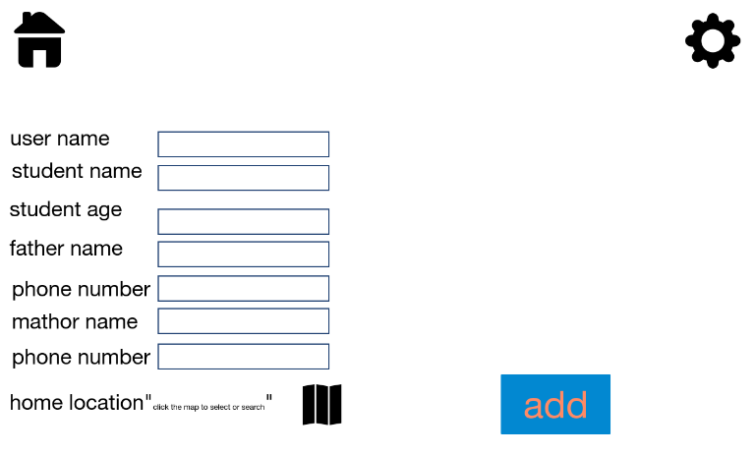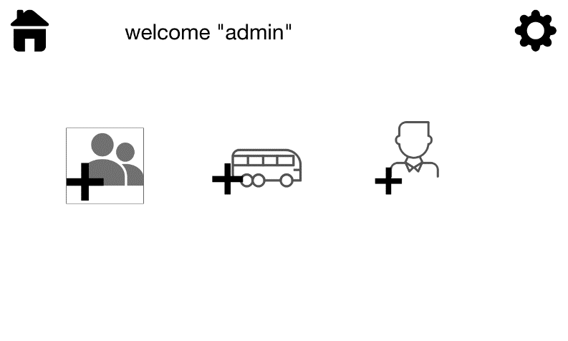

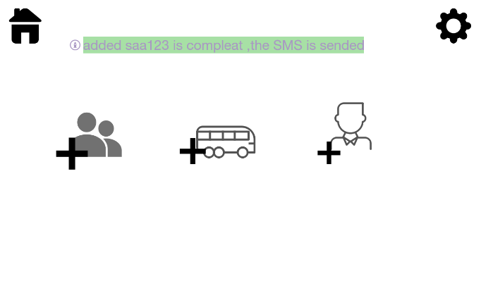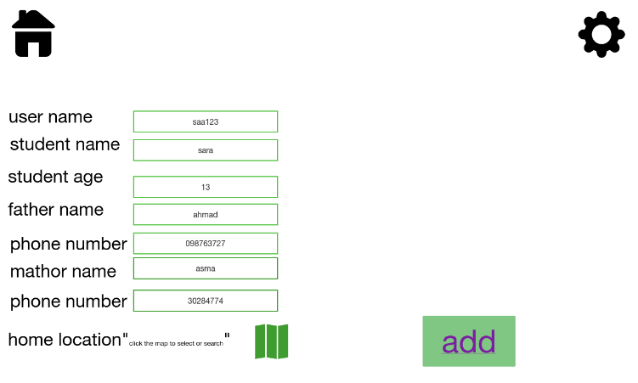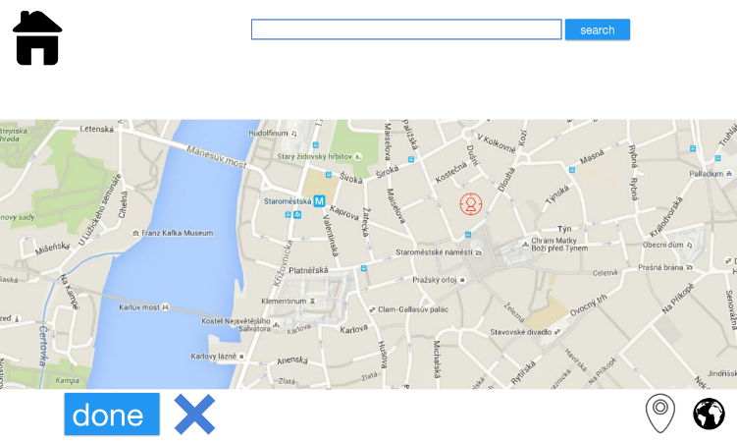

### 

### 2. VIEW CURRENT LOCATION use case

### 

### 

### 3.INFORM ABSENCE use case

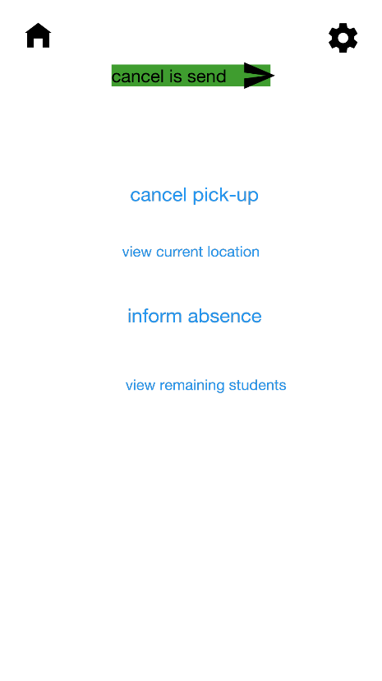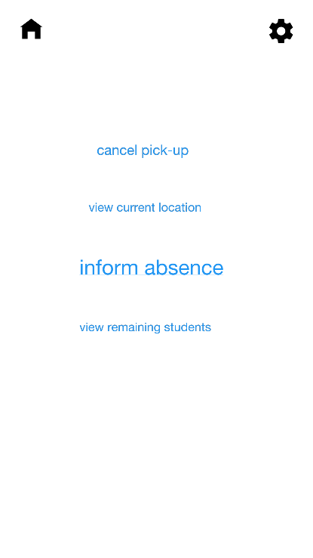

Send information is done

absence

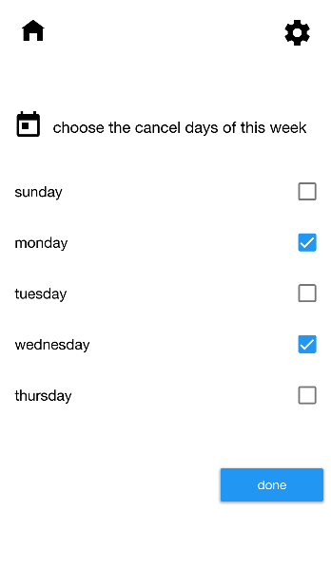

### 3.CHECK-OUT STUDENTS use case

### 

### 

### 3.1.2 Hardware Interfaces

### 3.1.3 Software Interfaces

## 3.2 Functional Requirements

***3.2.1 SBM2S website functions:***

3.2.1.1 The admin from the school shall be able to add bus drivers, parents, and buses to the system.

3.2.1.2 The admin shall be able to add the location of the parent’s son or daughter. when registering a new parent.

3.2.1.3 The admin shall be able to set the capacity for each bus.

3.2.1.4 The system shall allow the admin to add, view, edit and delete information of the bus driver and parent accounts.  
***3.2.2 SBM2S mobile app functions:***

3.2.2.1 The system shall allow the bus driver to check-in students upon pick up.   
3.2.2.2 The system shall allow the bus driver to check-out students upon arrival.   
3.2.2.3 The bus driver shall be able to view routes to the students’ home locations.  
3.2.2.4 The system shall allow the parents to see the current location of the bus carrying his/her child.  
3.2.2.5 The system shall allow the bus driver and the parent to access the system by their username/password .  
3.2.2.6 The system shall allow the bus driver and the parent to change their password at any time.  
3.2.2.7 The system shall allow the bus driver to view the route computed for his/her bus.  
3.2.2.8 The system shall allow the bus driver to view the location of the bus in real time.  
3.2.2.9 The system shall allow the bus driver to view the number of remaining students who still have not been checked out.  
3.2.2.10 The system shall allow the parents to view the number of the remaining students before his/her child turn for drop-off.  
3.2.2.11The system shall allow the parents to inform the system of the student’s absence.

3.2.2.12 The system shall allow the parents to request cancelling the pickup of his/her child any time before the actual pickup.  
3.2.2.13 The system shall allow the bus driver to confirm his availability at the beginning of the trip.  
3.2.2.14 The system shall allow the bus driver to notify the parents and the admin if there are any bus breakdowns during the trip.

***3.2.3 SBM2S system functions:***

3.2.3.1 The system shall send an SMS to the newly registered parent or bus driver which includes a unique username/password.

3.2.3.2 The system shall automatically assign students to buses by their home location.  
3.2.3.3 The system shall compute a route for each bus.

3.2.3.4 The system shall send SMS messages to the admin if the student is absent or if the bus breaks down.

3.2.3.5 The system shall create records for two trips every school day.

3.2.3.6 The system shall re-compute a temporary route for the assigned bus when a student is absent.

## 3.3 Use Cases and system boundary

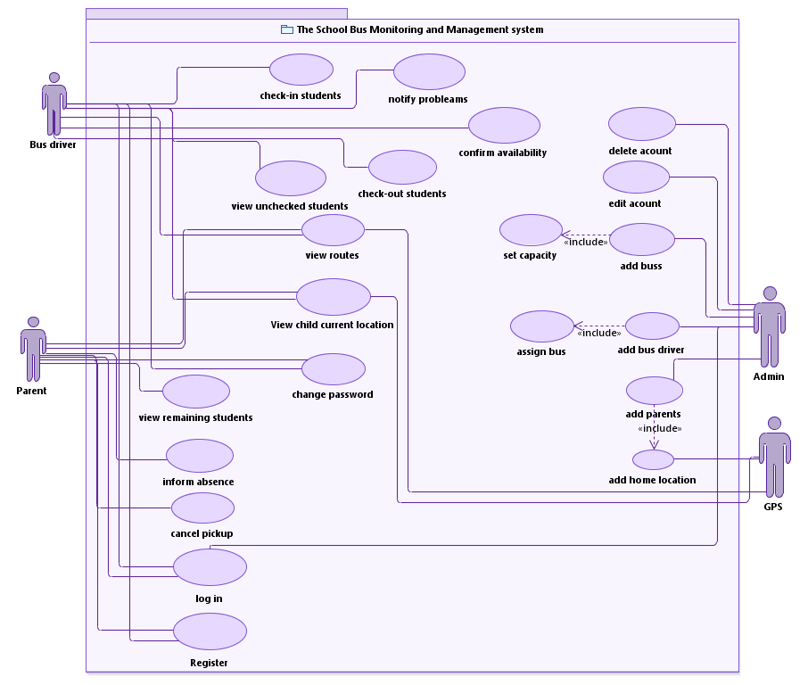

### C:\Users\noha\Dropbox\3\swe312\project\FINAL boundry digram.png

## 3.4 Classes / Objects

### 

## 

## 

## 3.5 Non-Functional Requirements

### 3.5.1 Performance

3.5.1.1 The bus tracking system must respond to 99% of user requests within 3 seconds of the request.

3.5.1.2 The bus tracking system’s location information for major busses must be less than 2 minutes old 80% of the time for major bus routes

### 3.5.2 Reliability

3.5.2.1 When the student is absent or the bus breakdown, the system shall re-compute a temporary route for the assigned bus driver and notify the bus driver with the new change.

3.5.2.2 The system should create the first trip before 1.5 hours of the start of the first class and lasts for two hours.   
3.5.2.3 The system should create the second trip before 0.5 hours of the end of the last class and lasts for two hours.

3.5.2.4 The system shall not let the admin exceed the seating capacity of the bus each bus can carry 20 students only.

### 3.5.3 Security

3.5.3.1 The password for the bus driver and the parents should exceed 8 characters with the use of both upper-case and lower-case letters.

### 3.5.4 Usability

3.5.4.1 New users should take fewer than 3 minutes to become familiar with the system.  
3.5.4.2 The admin should be able to access the system using a browser at any time.

### 3.5.6 Maintainability

### 3.5.7 Portability

### 3.5.3 Availability

## 3.6 Inverse Requirements

*Traceability between Use Case and Function/Feature*

## 3.7 Design Constraints

-The admin shall use a web access interface (a web page).  
-The system should be connected with a (a web-based mapping service) GPS.  
-The bus driver and the parents shall be able to access the system app via smartphone.

- Android operating system supports the SBM2S mobile app.

-The system should use an efficient algorithm for computing the routs such as those for Capacitated Vehicle Routing Problem (CVRP).

## 3.8 Logical Database Requirements

*Will a database be used? If so, what logical requirements exist for data formats, storage capabilities, data retention, data integrity, etc.*

## 3.9 Other Requirements

*Catchall section for any additional requirements.*

# 4. Analysis Models

## 4.1 Sequence Diagrams

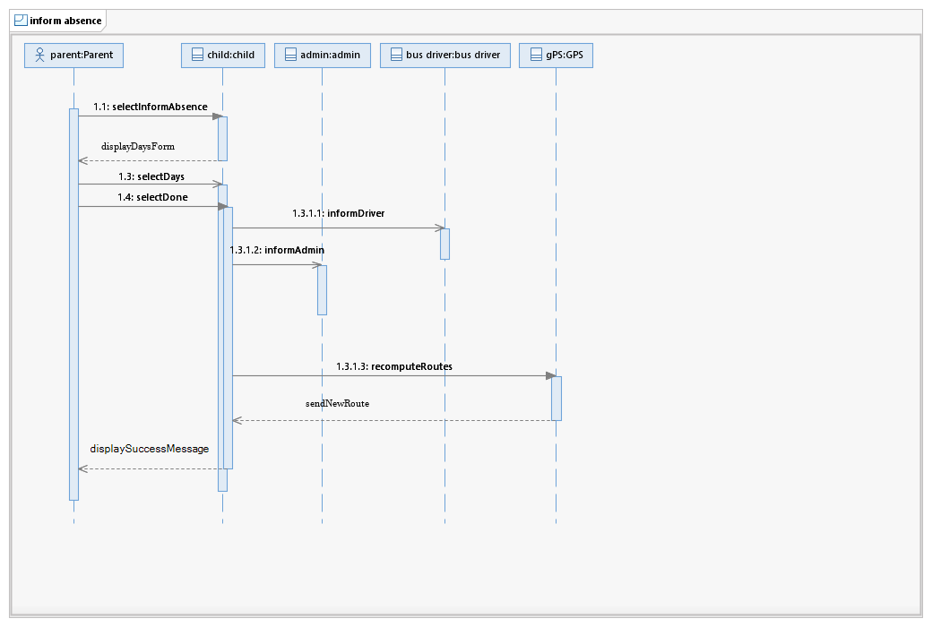

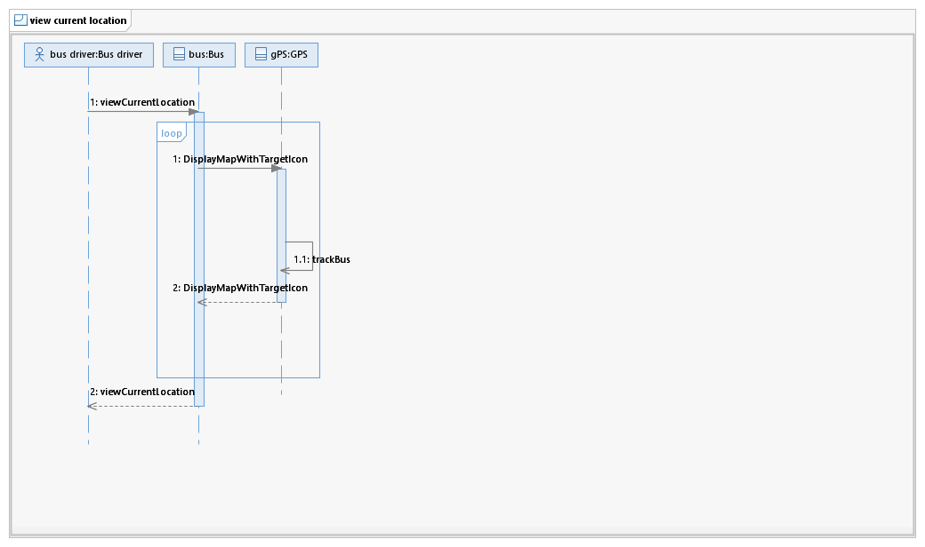

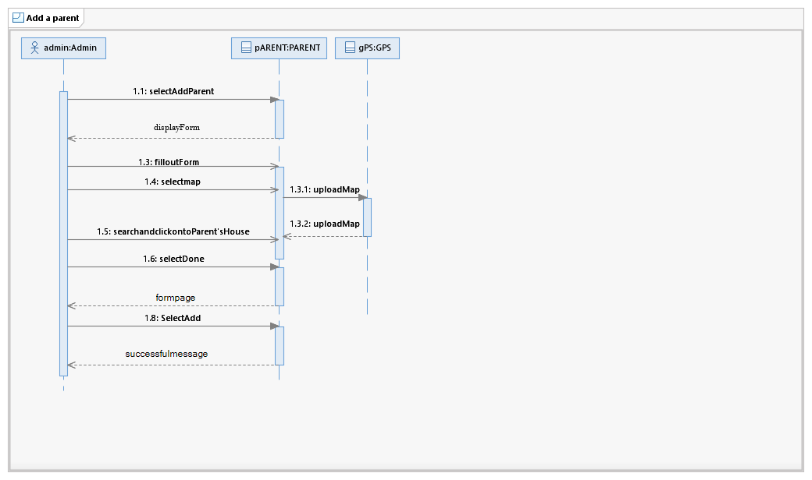

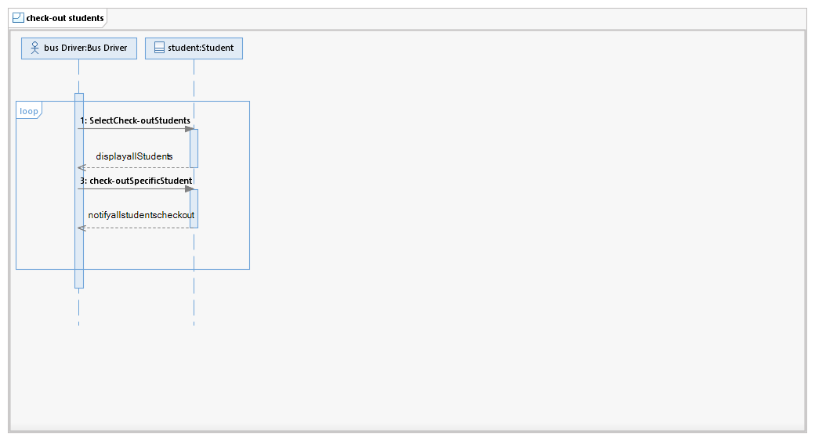

## 4.3 Activity Diagram

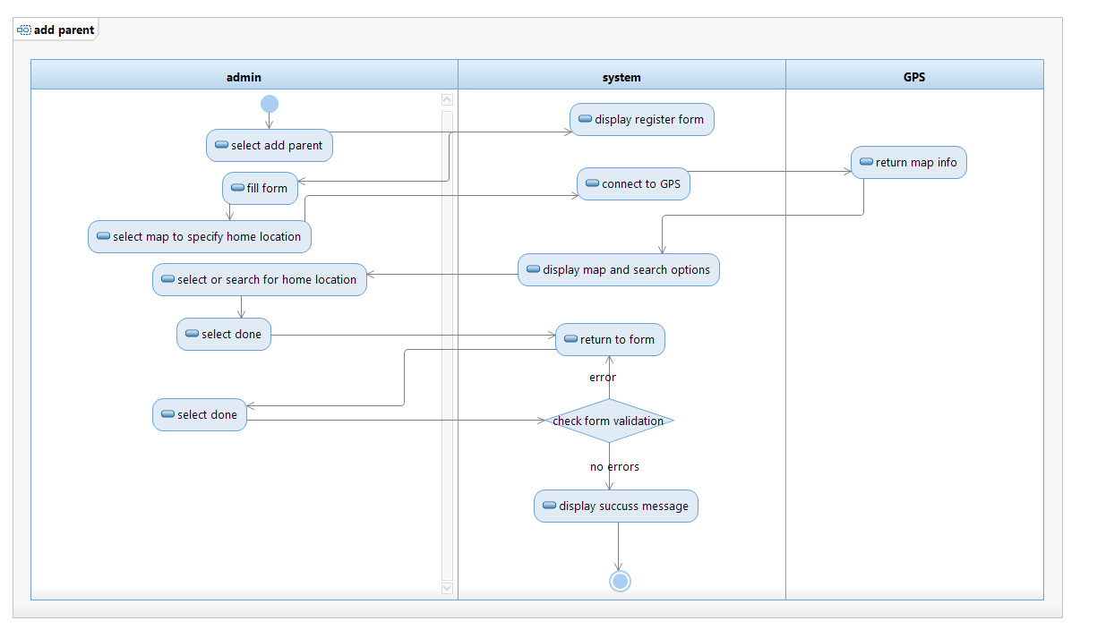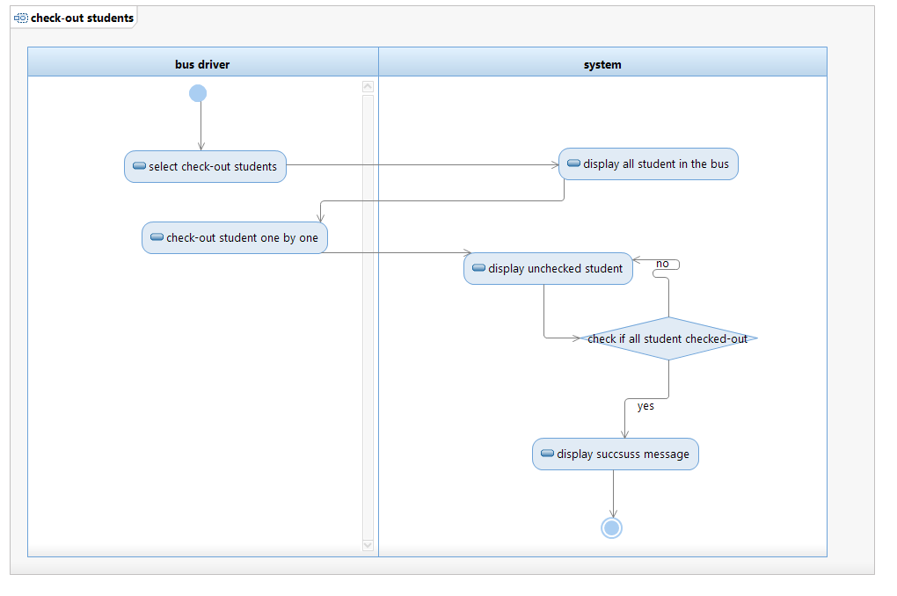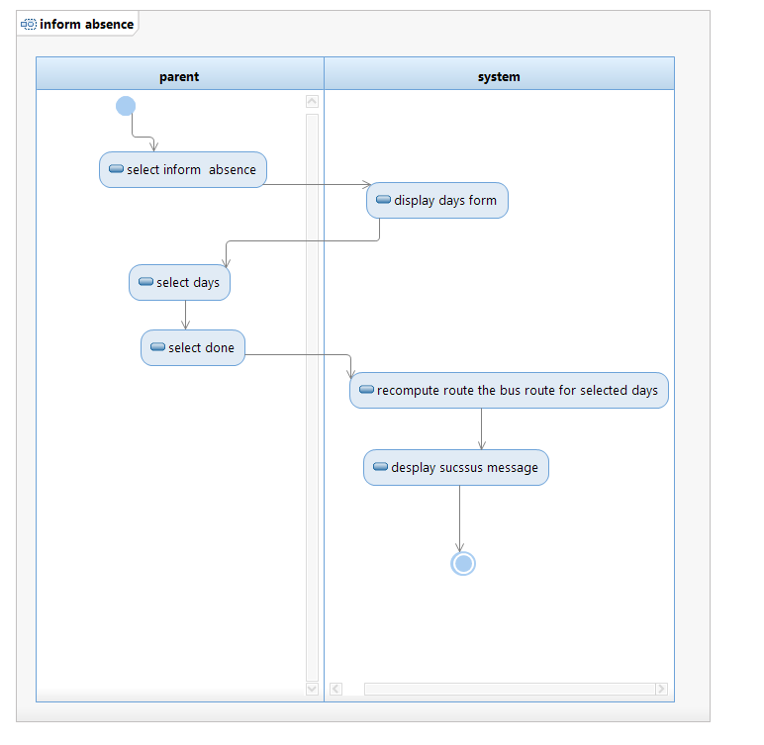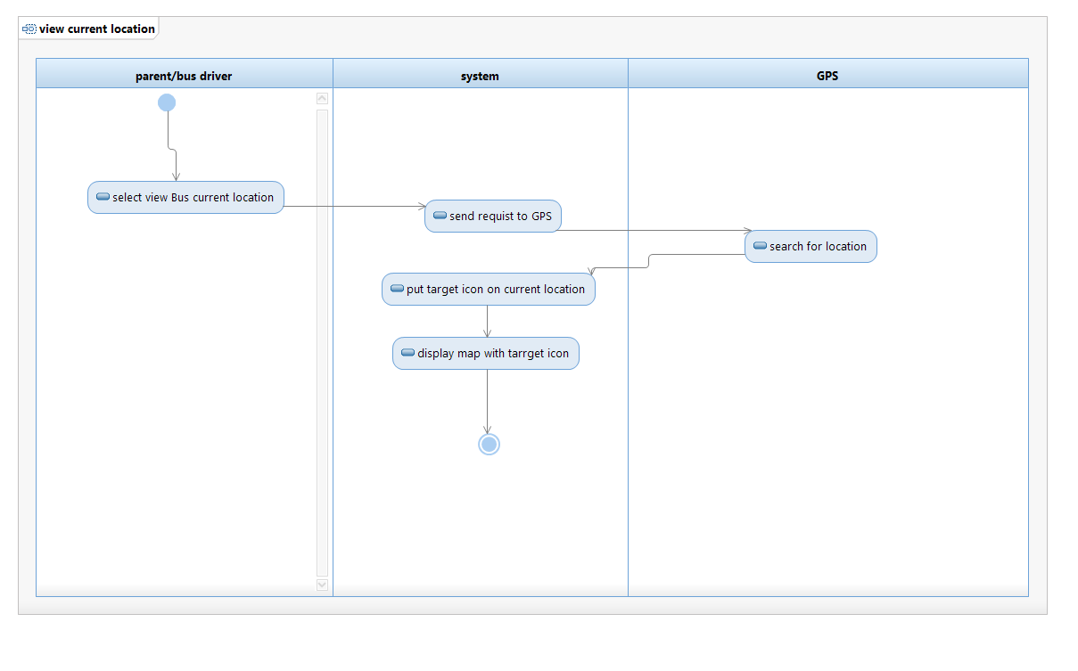

# 5. Change Management Process

*Identify and describe the process that will be used to update the SRS, as needed, when project scope or requirements change. Who can submit changes and by what means, and how will these changes be approved.*

# A. Appendices

## A.1 Appendix 1

web.uvic.ca/~cshen/seng321/meeting/Bus%20Tracking%20System%20RS%201.0.doc

## A.2 Appendix 2

www.utdallas.edu/~chung/RE/Presentations07S/Team_1_Doc/.../SRS4.0.doc